# Design:

My game will be a conquest based game, in which players use armies to attack territories owned by other players. The outcome of battles between players armies are based on chance. There will be different ways of winning depending on the game mode, and different maps. I will also have artificial intelligence.

A few key data structures in my program are:

Map.Players – Circle Queue - Is a queue so that it loops through when deciding whose turn it is

Map.Continents - List

Continent.Territories – List – Each continent in the Map.Continents list has its own list for territories inside the continent

Player.Territories – List

Territory.Pixels – Array – Each territory in the Continent.Territories list has an array for all of the pixels. Each item in the array has an x and a y co-ordinate.

I will not use a database in my product as I do not feel that it is necessary. I can use lists of territory objects and continent objects as parameters in my map class. I can also use an array of pixels as a parameter of my territory class. These are the only pieces of data that are a significant size.

## Function Table:

Game Class:

|  |  |  |  |
| --- | --- | --- | --- |
| Function | Parameters | Returns | Purpose |
| InitialiseMap | Game.Map | None | Loads the territories and continents from the Map Class |
| InitialiseGamemode | Game.Gamemode | None | Loads (or randomly selects) the focus for the game. |
| AssignTerritories | Game.Players  Game.Map | None | Assigns each player a random territory until they have all been assigned. |
| AssignArmies | Game.Players  Game.Map | None | Allows the Player/AI place their armies in the territories that they choose. |
| ReinforceStage | Player  Game.Map | None | Allows the Player/AI place their reinforcement armies in the territories that they choose. |
| AttackStage | Player  Game.Map | None | Allows the Player/AI attack enemy territories that they choose. |
| MoveStage | Player  Game.Map | None | Allows the Player/AI move armies from whichever territories they chose |
| Attack | Player  Attacker  Target  Amount | None | Does the action of fighting the battles, including removing dead armies from either the attacker or the target, and rolling dice to determine the outcome. |
| CheckWin | Player  TurnCount  Game.Map  Game.Gamemode | Won (Boolean)  Winner | Checks, depending on the gamemode, whether or not the player whose turn it is has met the win conditions. |
| CheckLose | Game.Players | Loser | Checks if any of the players have lost all of their territories. |
| Play | Game.Players  Game.Map  Game.Gamemode | None | Runs the game until the end |

Map Class:

|  |  |  |  |
| --- | --- | --- | --- |
| Function | Parameters | Returns | Purpose |
| ShowMap | Map.Continents  Map.Territories  Focus | None | Displays the map, drawing out territories and continents, and outlining the focus for the gamemode. |
| ShowOverlay | Player  Stage  Text  Button | None | Displays the overlay, including whose turn it is, what stage they are in, and any buttons or text relevant to the game that needs to be displayed. |
| DisplayLoser | Loser | None | Display a screen saying that the player has been eliminated |
| DisplayWinner | Winner | None | Display a screen showing that a player has won the game. |
| DisplayGamemode | Gamemode | None | Displays a screen the shows what gamemode is being played, and tells the players how to win. |

Player Class:

|  |  |  |  |
| --- | --- | --- | --- |
| Function | Parameters | Returns | Purpose |
| GenerateAssign | Game.Map  Player | Territory | Decides which territory the AI should assign its armies |
| Generate-  Reinforcement | Game.Map  Player | Territory | Decides which territory the AI should place its reinforcements |
| GenerateAttack | Game.Map  Player | Attacker  Target  Amount | Decides whether the AI should attack, and if it should, where and with how many armies. |
| GenerateMove | Game.Map  Player | LowestT  HighestT  amount | Decides whether the AI should move territories, and if it should, where from, where to, and with how many armies. |
| GetAssignChoice | Game.Map  Player | Territory | Allows the player to choose a territory to assign armies |
| GetReinforceChoice | Game.Map  Player | Territory | Allows the player to choose a territory to reinforce with armies |
| GetAttackChoice | Game.Map  Player | Attacker  Target  Amount | Allows the player to choose whether to attack, and if so, where to, where from and with how many armies. |
| GetMoveChoice | Game.Map | MoveOrigin  MoveTarget  Amount | Allows the player to choose whether to move armies, and if so, where to, where from and with how many armies. |
| Connected | Origin  Target | Connect (Boolean) | Finds out whether two territories are connected via a link of friendly territories. |

Territory Class:

|  |  |  |  |
| --- | --- | --- | --- |
| Function | Parameters | Returns | Purpose |
| Getdefensevalue | Focus | Value | Work out how which territory is the best to defend (based on risk/reward of owning the territory) |
| ContinentCheck | Player | ContinentOwn | Finds out whether a player owns a continent or not |
| GetAttackValue | Player,Attacker | Value | Works out whether it is worth attacking a territory (based on risk/reward) |

Continent Class:

|  |  |  |  |
| --- | --- | --- | --- |
| Function | Parameters | Returns | Purpose |
| GetContinentBonus | Territories | Bonus | Calculate the continent bonus based on number of territories |

Menu Class:

|  |  |  |  |
| --- | --- | --- | --- |
| Function | Parameters | Returns | Purpose |
| Mainmenu | None | None | Allows the player to navigate through the mainmenu |
| Singleplayer | None | None | Allows the player to navigate through the singleplayer menu |
| Multiplayer | None | None | Allows the player to navigate through the multiplayer menu |
| Rules | None | None | Allows the player to navigate through the rules menu |

Random Map Class:

|  |  |  |  |
| --- | --- | --- | --- |
| Function | Parameters | Returns | Purpose |
| GenerateContinents | None | None | Creates continents randomly |
| PlaceContinents | None | None | Places the continents on the map randomly |
| GenerateTerritories | None | None | Creates territories randomly |
| PlaceTerritories | None | None | Places the territories on the map randomly |
| AssignTerritories | None | None | Assigns territories to continents |
| InitialiseNeighbours | None | None | If neighbours are touching |
| CreatePixels | None | None | Places pixels in the territories on the map |
| CleanPixels | None | None | Cleans the land mass in each territory, so it looks better |

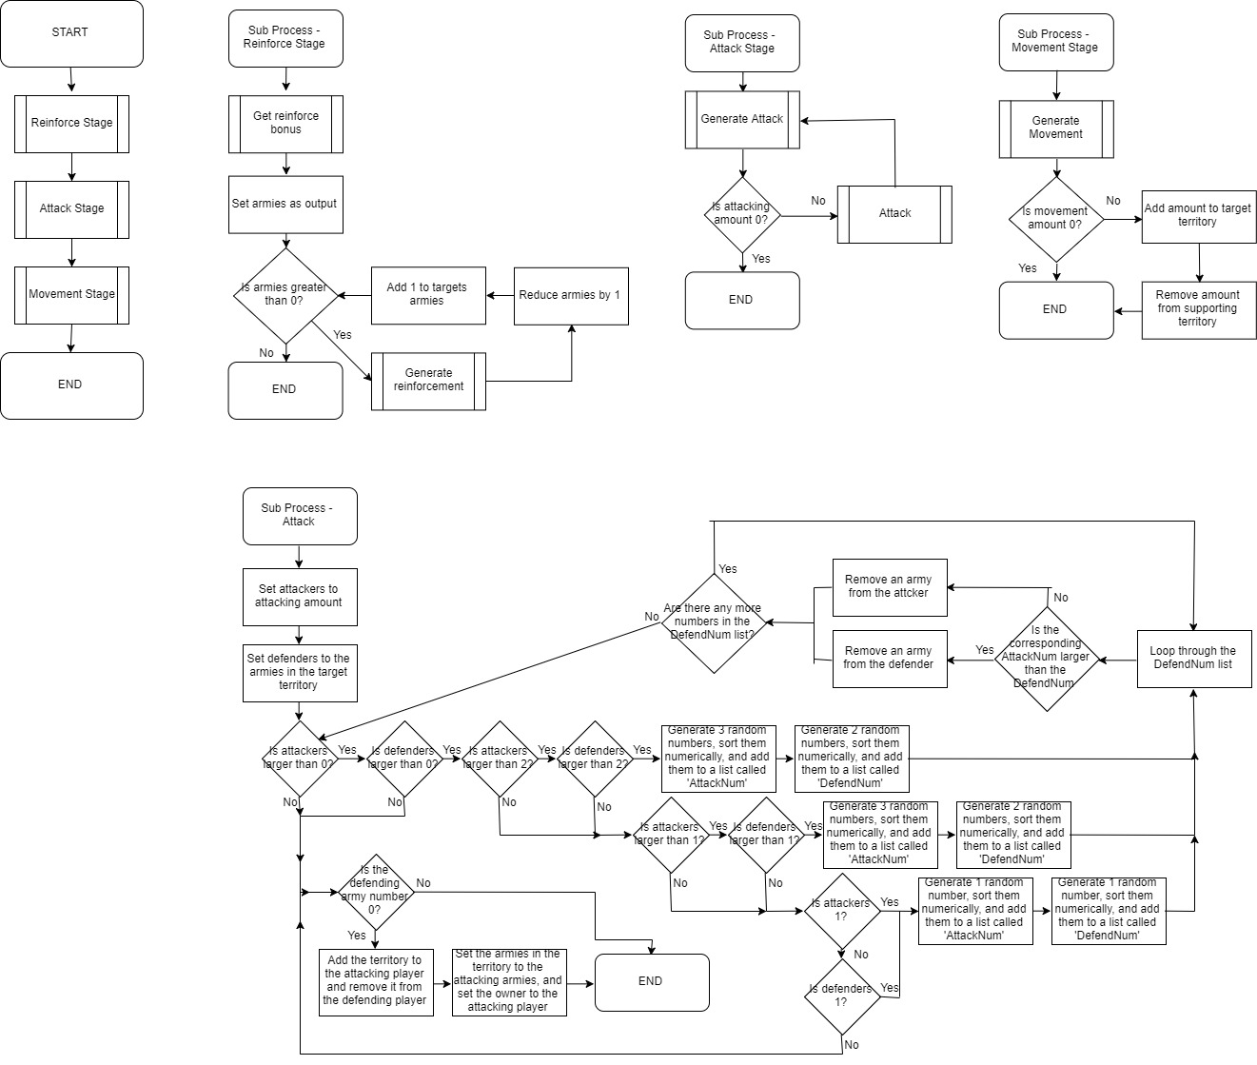Artificial Intelligence:





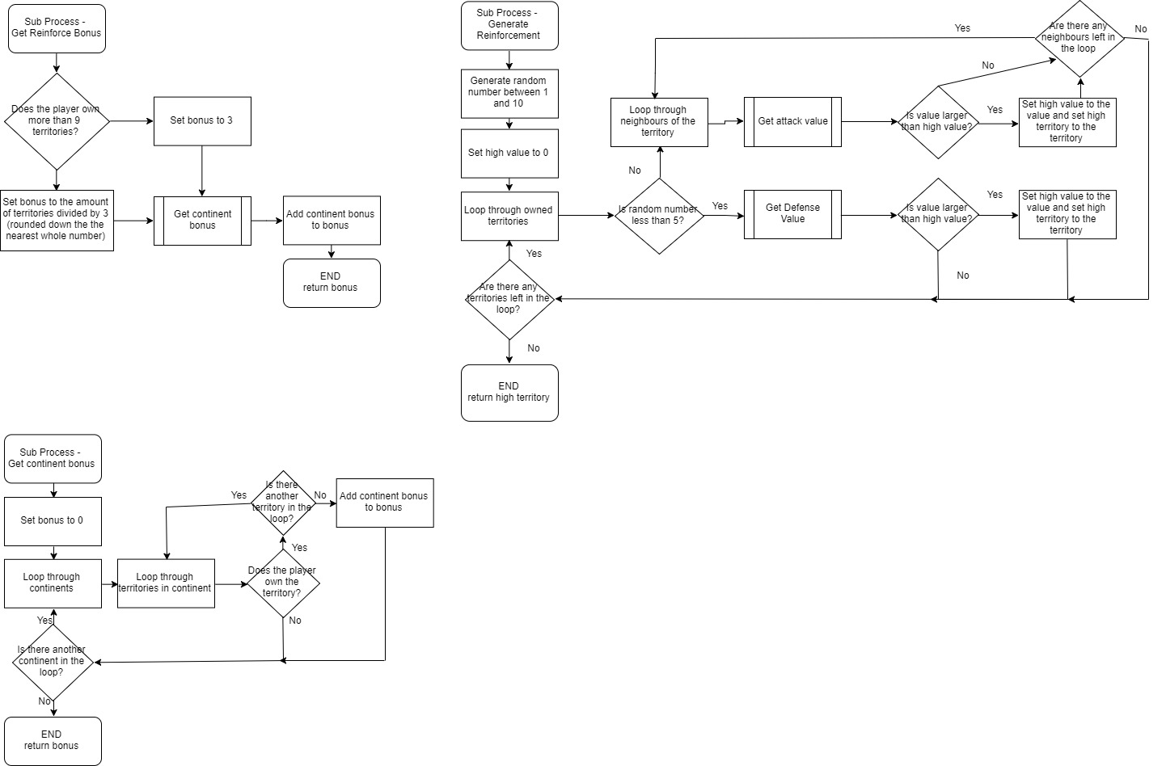

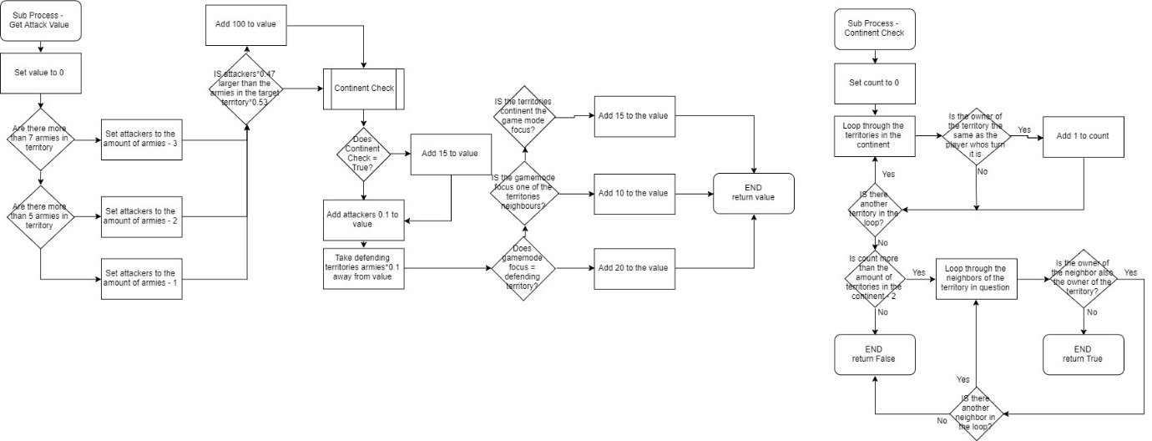



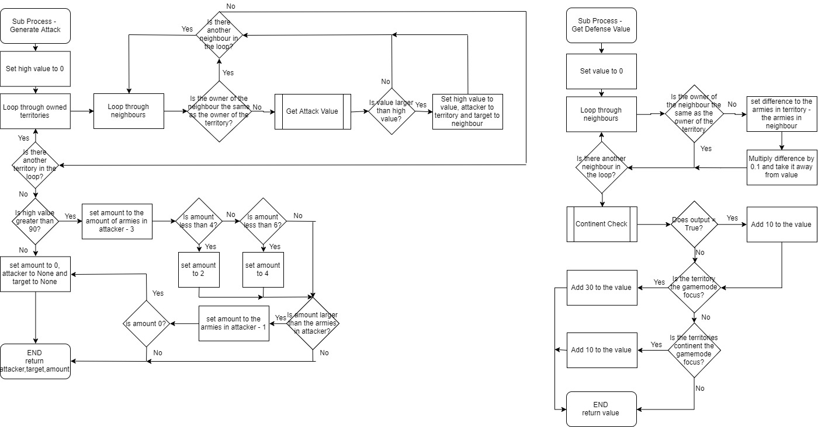





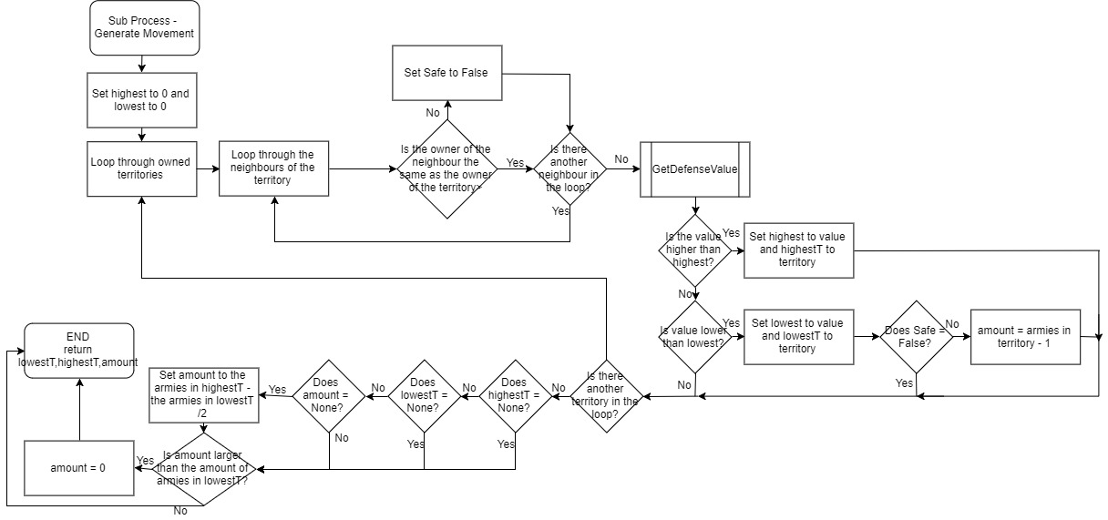

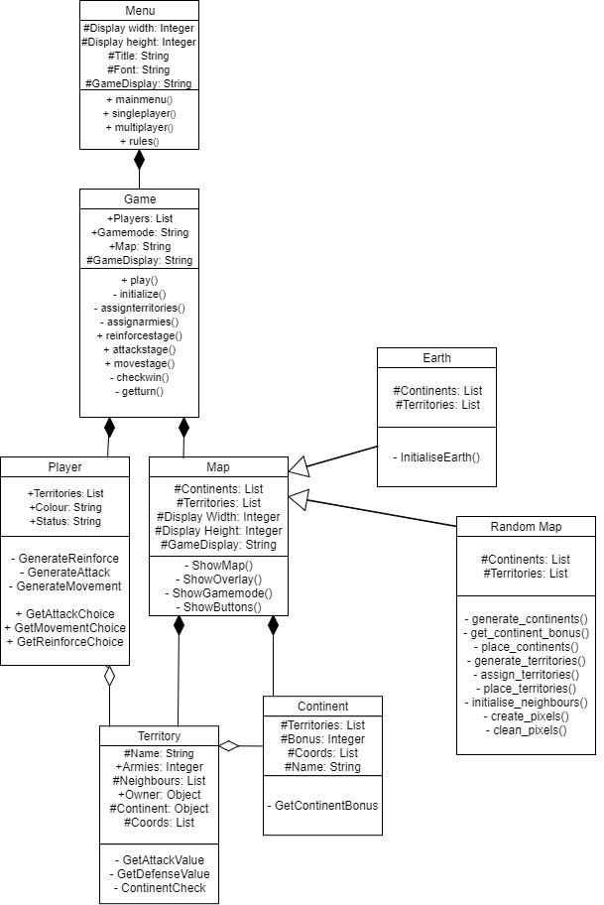

Class Diagrams

I will have a menu class so that the user can navigate between different menus, such as singleplayer, multiplayer and the rules. From this class the player will be able to choose game modes, player numbers and maps.

I will have a game class to control all functions of the actual game, including attacking, checking for win conditions and directing the AI.

I will have a player class to orient turns, and to keep track of who owns which territory. This class will also be used for controlling the AI, and managing player input. This is also important for displaying the board as each player will have a colour.

I will have a map class which will mainly be used for displaying everything while the game is happening, and for controlling all of the input during the game, including buttons for skipping, and selecting numbers of armies. This class will also have subclasses: Earth and Random Map.

The Earth Class initialises a pre-built map that resembles Earth. All of the continents and territories will be pre-set in the subclass.

The Random Map Class will randomly generate and build a map, while ensuring that it is reasonable and fair for all players. It will assign a random amount of territories to a random amount of continents.

I will have a territory class to keep track of data about each territory including the owner, amount of armies stationed there, neighbours and co-ordinates. It will also be used to calculate values which will affect the AI’s choices.

I will have a continent class to keep track of data about each continent, including the territories it contains, the bonus for owning every continent inside it, and its co-ordinates.

Display:

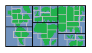When displaying the map, each territory and continent will have an x,y,w,h co-ordinate, which will draw a square in position (x,y) on the screen with width w and height h. This square will dictate the area that is in the territory/continent. There will also be the land mass of each territory

Attack Stage

Red’s Turn

Red’s Turn